
Proposal Content:
1. Organisation Overview:
- Name: Mandys Salon
- Provide a brief history of the organisation.
Mandys Salon was first established in 2022 as a home-based hair service in Parktown, Johannesburg.
What began with one chair, one dream, and a passion for beauty quickly grew thanks to amazing client support.
In 2023 we opened our small storefront to serve our community better. Today we are proud to be a place where everyone can feel
beautiful, confident, and cared for.
- Mission and vision statements.
To deliver affordable, high-quality beauty services that make everyone feel confident and valued.
We believe that self-care is not a luxury, it's a necessity.

To be the leading community salon in Johannesburg that empowers people through beauty, confidence, and care.
We aim to create a welcoming space where every client leaves feeling their best.
- Target audience.
Our target audience includes men, women, and students in Johannesburg and surrounding areas who are looking for
affordable, professional, and high-quality hair and beauty services.
We especially focus on clients who value self-care, hygiene, friendly service, and a relaxing salon experience.
2. Website Goals and Objectives:
- Define specific goals for the website (e.g., increase website traffic, generate leads, sell products, or provide valuable information).
- Determine and present key performance indicators (KPIs) to measure success.
1. Generate Leads & Bookings: Allow clients to easily book appointments online through the Book-appointment.html page to reduce wait times.
2. Provide Valuable Information: Inform visitors about our services, pricing, opening hours, location, and "How We Operate" including hygiene standards and consultation process.
3. Promote Monthly Specials: Use the Monthly-special.html page to showcase discounts and attract new clients.
4. Build Brand Trust: Showcase our story, mission, and values on the About-us.html page to connect with the community.
5. Increase Website Traffic: Use the Gallery.html to display before/after work and encourage social sharing to bring more people to the salon.

KPIs:
Number of Online Bookings: Track how many appointments come through the website per month.
Website Traffic: Number of visitors to Home, Services, and Gallery pages.
Contact Form/WhatsApp Clicks: How many people click to contact us from the Contact.html page.
3. Current Website Analysis (if applicable):
- Analyse strengths and weaknesses of the existing website.
- Strength: The website provides a simple navigation for all webpages.
- Weakness: Part 1 of the POE only states to use html only ; therefor the pages look simple and plain without the use of CSS.

- Identify areas for improvement based on the weaknesses identified.
- Add a booking table for the book-appointment website to make it look more classy.
- Add more details to webpages like the About-us .
4. Proposed Website Features and Functionality:
  - Outline essential features (e.g., homepage, about us, contact page, products/services page) and the desired functionality.
  - Homepage: Shows a photo of the Saloon and the slogan.
  - About Us: Company story, mission, vision, "How We Operate", salon hours.
  - Services: List of all hair, nail, and beauty services with descriptions and prices.
  - Gallery: Photos of completed styles and treatments to showcase quality of work and services that our business provides.
  - Contact: Full contact details - address, phone, WhatsApp, email, map location, and opening hours.
  - Book Appointment: Online form for clients to request bookings instead of only calling.
  - Monthly Specials: Page to promote discounts and packages each month to attract new clients.
  - Functionality: Consistent navigation menu on all pages, clickable links, and mobile-friendly layout.
5. Design and User Experience:
  - Discuss the overall design aesthetic and branding, highlighting the following:
  - Colour Scheme: Beige - Background color for warmth and calm
Hotpink - Main accents, headings, and thick <hr> lines

  - Typography: Use HTML heading tags <h1>, <h2>, <h3> for hierarchy
Main titles: Italic and <u>underline</u>
Body text: Simple, readable, no fancy fonts to keep it fast

  - Layout and Design: <hr width="80%" color="hotpink"> to separate major sections<hr width="60%" color="plum"> to separate smaller sections. Emojis used for personality.

  - User experience considerations (e.g., navigation, layout, colour scheme).

  - Navigation: Top menu on every page for easy access
  - Layout: Short paragraphs, bullet points, clear headings
  - Colour scheme: Soft salon colors that are easy on the eyes
  - Call-to-Action: "Book Appointment" link at bottom of every page

  - Develop low-fidelity wireframes to visualise the website's layout and information hierarchy.

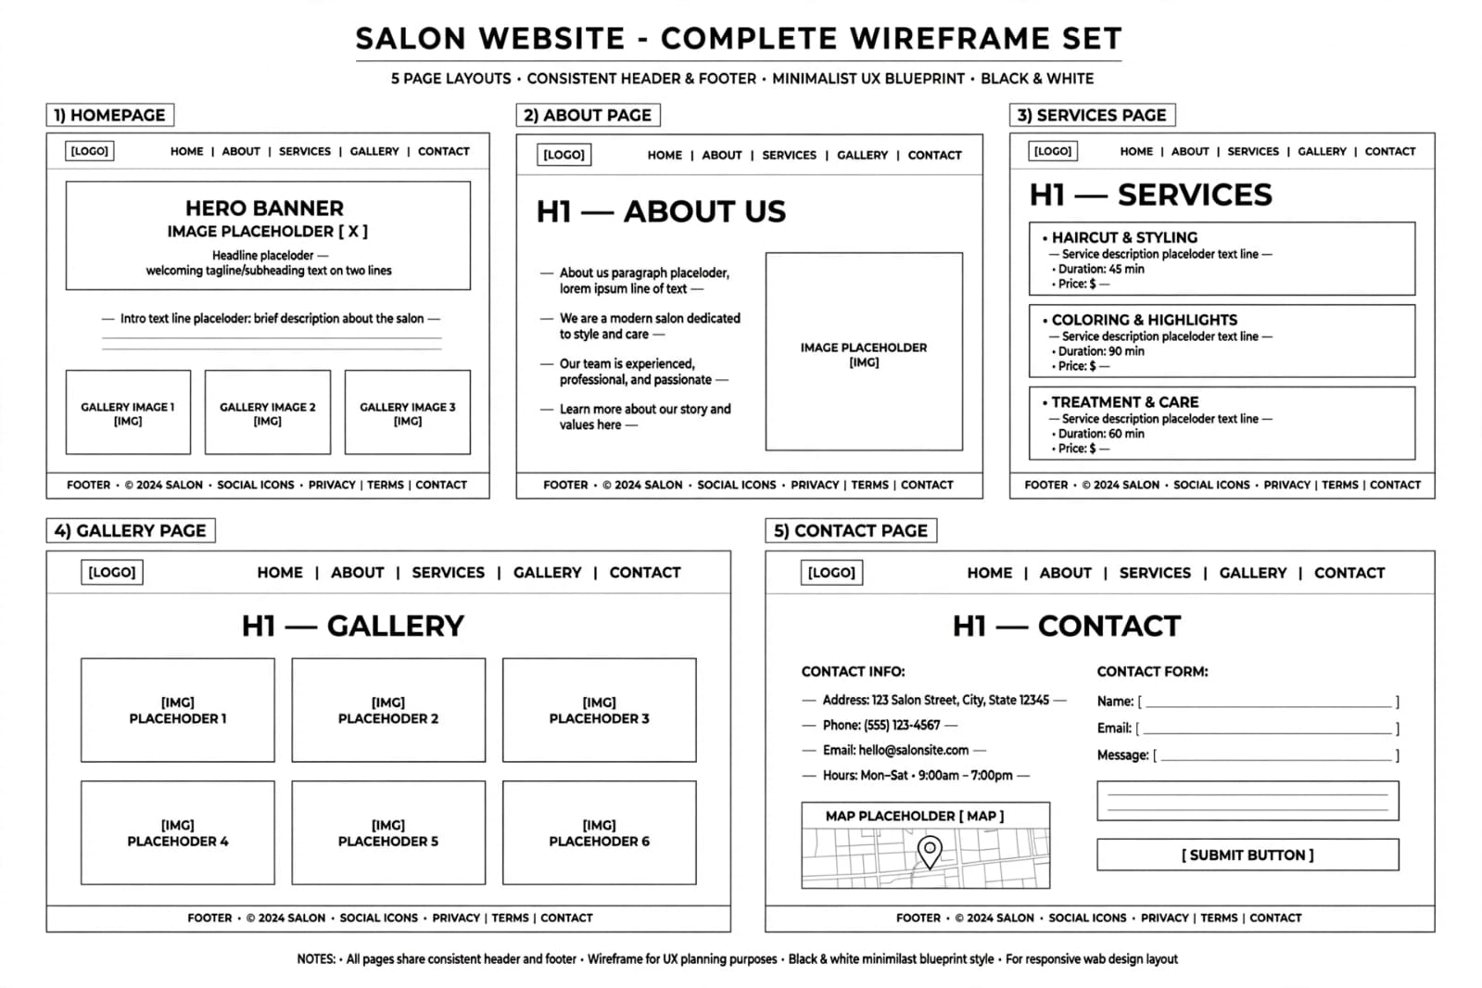
6. Technical Requirements:
- Identify hosting and domain name requirements and programming languages Hosting: Free hosting via GitHub Pages for the assignment . Domain Name: Proposed: www.mandyssalon.co.za. Programming Languages: HTML5 - Structure for all 7 pages. Inline CSS - For background-color, color, width, height. Frameworks: None. Pure HTML/CSS to keep it simple for a small business to maintain. Storage: Images stored in /images folder.

7. Timeline and Milestones:
  - Create a realistic project timeline with key milestones that follow the timeline during the subject's submission dates.

The Mandys Salon website was developed within a 1-week period to meet the assignment deadline. In the first 2 days, the planning and content gathering was done. This included writing the About Us, Services, and Contact information, and collecting the salon logo and images. The next 3 days were used for website development, where all 7 HTML pages were coded with navigation, branding colors, and links. The final 2 days were used for testing, proofreading, and making final edits before uploading and submitting the website with the proposal document.
8. Budget:
  - Estimate the budget for development, hosting, and maintenance (while this is a series of assignments, the budget should reflect realistic amounts based on your research).

The estimated budget for the Mandys Salon website is kept low since it was developed as a student project. The website was built using free tools with HTML and inline CSS, so there were no development costs
9. References:
  - References listed here are unique to the chosen organisation and the researched documentation of the Website Project Proposal. The references listed in this document and the general references used to complete Part 1 will be compiled in the README.md document in the repository for the entire PoE.

- W3Schools. HTML Reference for <hr>, <font>, <center> tags. w3schools.com.
- C:\Users\user\OneDrive - ADvTECH Ltd\Desktop\Mandys saloon\Images\cluster lashes.jpg
- "C:\Users\user\OneDrive - ADvTECH Ltd\Desktop\Mandys saloon\Images\fulani.jpg"

